**Title:** Multiplication of matrix and vector using CUDA C.

**Outcome:** At the end of this seesion students will be able to:

1) Understand CUDA structure.

2) Understand programming structure of CPU & GPU.

3) Able to write the code & test it for result.

4) Compare execution time for sequential & parallel programs.

**Theory:**

* CUDA Architecture: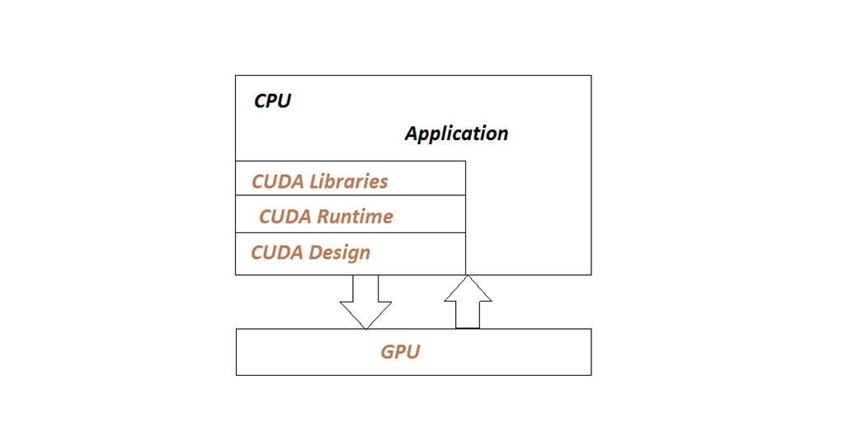
  + Programming Structure of GPU & CPU:

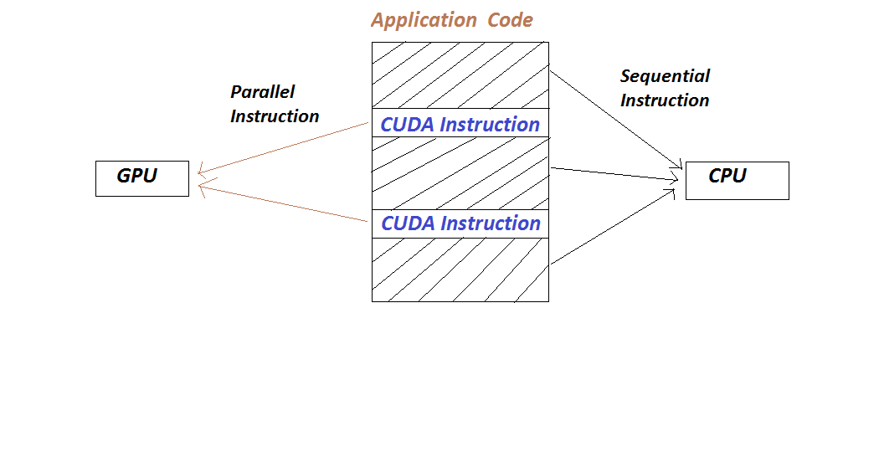

* CUDA Kernel:

The function which are executed on GPU are called as kernels.Kernels are full program or function invoke by the CPU and executed on GPU.A kernal is executed N number of times in parallel on GPU by using N number of threads.

Invocation: kernel_name<<<grid,block>>>(argument,list);

kernel is defined as:

_global_voidkernel_name(arguments)

{

.........

}

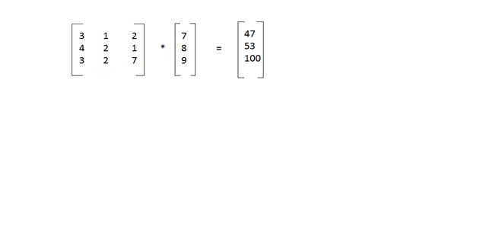

Task graph:

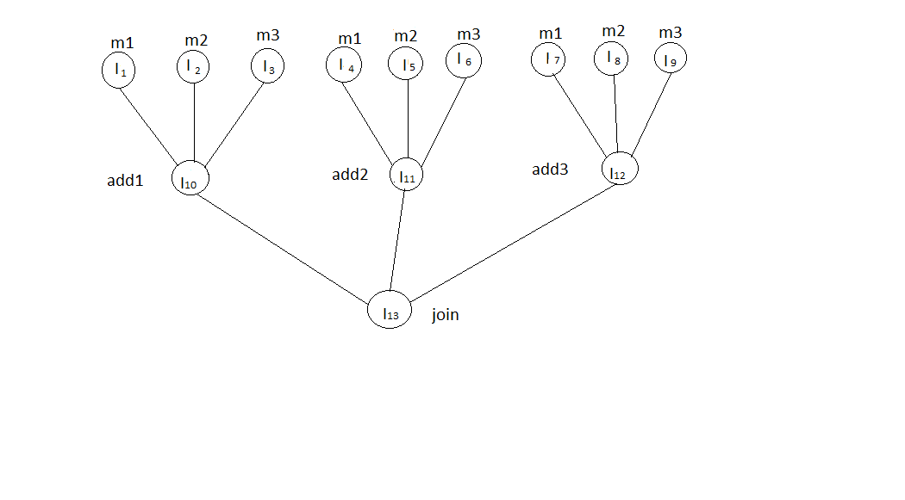

**Procedure:**

1) Write a program using text editor, name the source code with .cu extension.

2) Compile the program using nvcc compiler.

3) Execute the program.

4) Verify the result.

**Theory**

**Conclusion:**

Execution time for parallel and serial for multiplication of matrix and vector is compared. Performance of parallel program is more as compared to sequential addition.